1. Trunking factor for stranded thermosetting BS 7211, 50 x 1.5mm, 25 x 10mm and 10 x 16mm
2. What depth must cables be buried if they are outside of the 150mm zone
3. What thickness insulation must not be exceeded to be classed as reference method of 100
4. What is the electricity supply earthing arrangement below

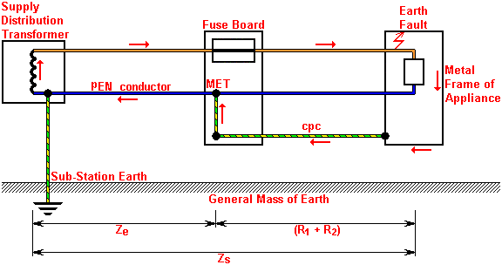

1. If a TN-C S supply has Line conductor size of 16mm what minimum size shall be
2. the main earthing conductor
3. the main bonding conductor
4. If a circuit conductor size of 10mm what minimum size shall be supplementary bonding conductor be
5. If mechanically protected from an extraneous to extraneous conductive part
6. If not mechanically protected from an exposed to extraneous conductive part
7. What is the BS number for a bonding conductor label
8. What is the applied percentage of diversity for a lighting circuit in a small hotel
9. What is the maximum measured earth fault loop impedance for BS EN 60898 type B MCB rated at 40 amps
10. What is the minimum height for a light fitting to be installed in a bathroom if it is to be classed as outside of the zone
11. A BS EN 61009 RCBO should operate in less than how many milli-seconds at 100% the rated tripping current
12. What is the maximum spacing of supports for a 20mm steel conduit ran vertically
13. What is the de-rating factor for Ci of insulation length no greater than 50mm
14. What British Standard of fuse is the factor Cf applied
15. Cf has a rating factor of